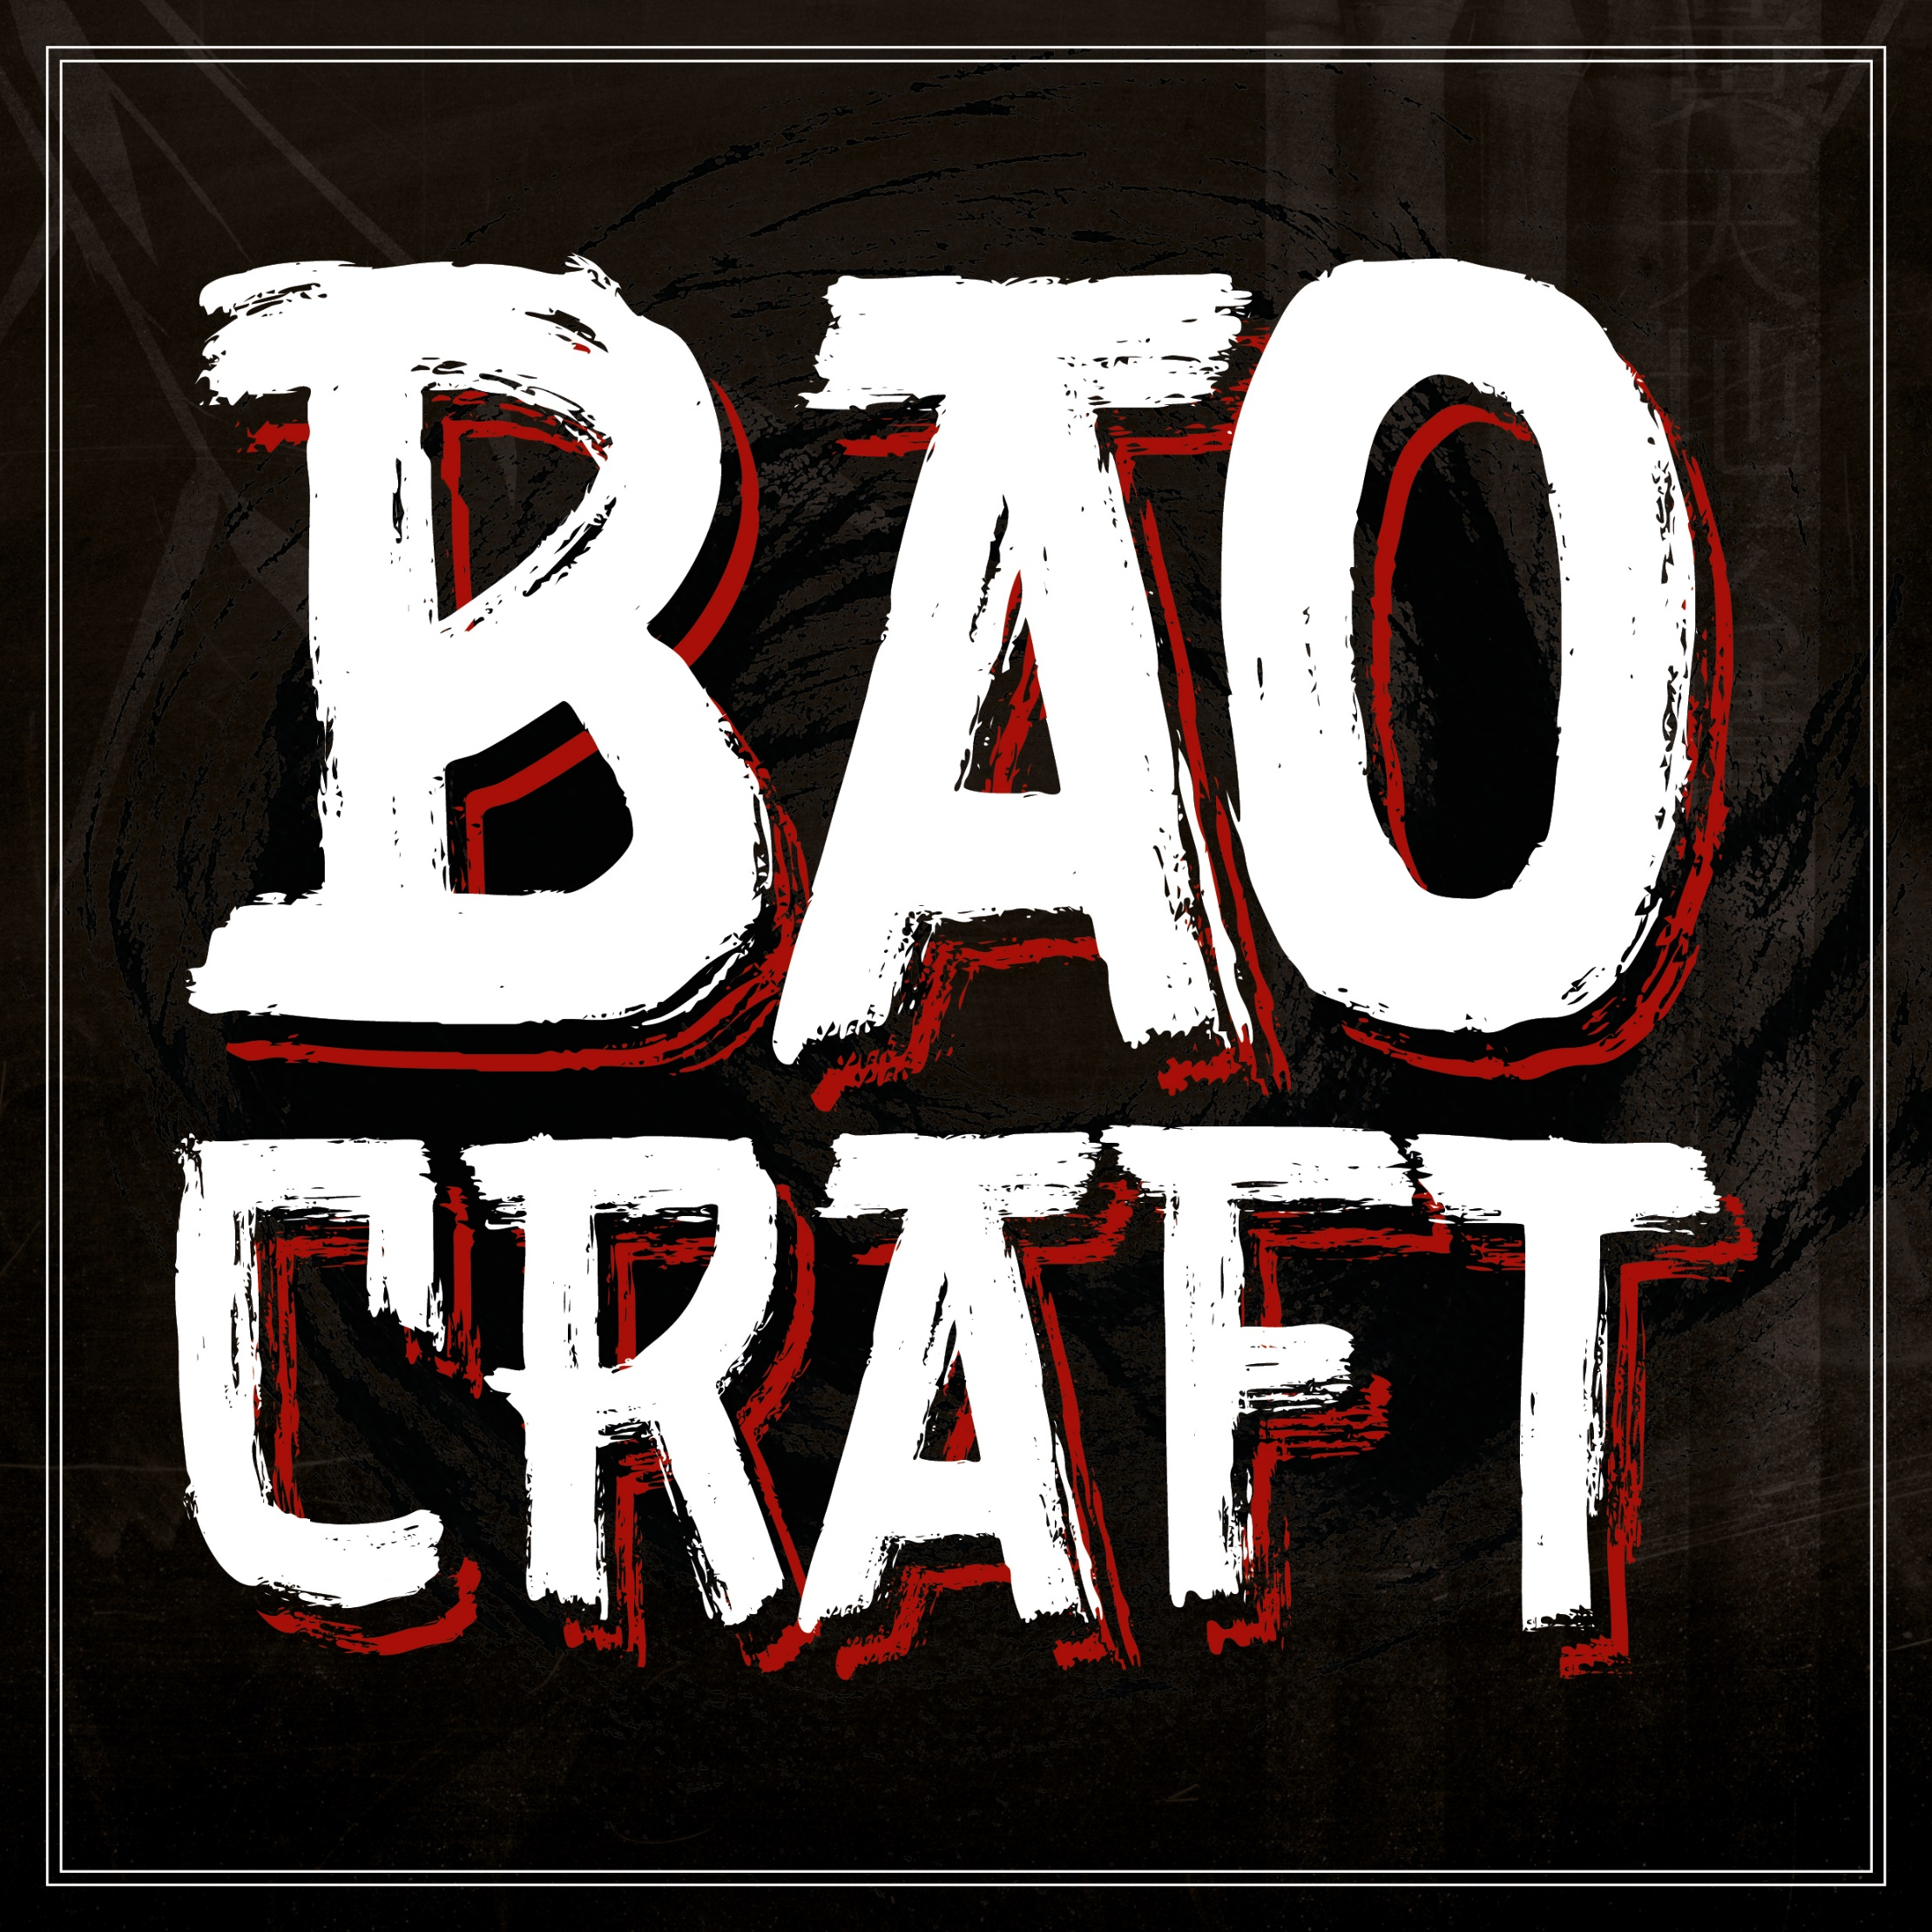

**BAO-GERS**

*A lotus leaf steamed bun shaped and cut as a traditional burger bun giving all the flavour of Taiwanese street food in the comfort of a burger shape served with Asian Slaw*

**£8.95**

**CHOOSE YOUR MEAT**

Gochoujang pork belly

Beetroot burger

Panko chicken

**LET’S JAZZ IT UP**

**SRIRACHA**

*Caramelised kimchi, Sriracha, Asian slaw & coriander*

**SWEET CHILLI** vg

*Sweet chilli sauce, pickled red cabbage & Asian slaw*

**KOREAN BBQ** vg

*Korean BBQ sauce, lettuce, pickled cucumber & crushed peanuts*

**PANANG CURRY**

*Panang curry mayo, Asian slaw, pickled cucumber,*

*fresh chillies & crushed peanuts*

**GARLIC** vg

*Garlic mayo, lettuce, pickled carrot, crispy onion & garlic flakes*

**TONKATSU**

*Shredded cabbage, miso mustard, tonkatsu sauce & pickled carrot*

**BOACRAFT BOX**

**BAO BOX CANNY £12.00**

Perfect for 1

**Bao or Rice box designed how you like it,**

**Poutine, Katsu or Kimchi Fries and a drink**

**BAO BOX CRAFTY £24.00**

Perfect for 2

**Gyozas, Firecracker Cauliflower,**

**Bao or Rice box each designed how you like it, House spiced fries and choice of drink each**

**Upgrade any soft drink to a 500ml Craft Beer for £3**

**STREET FOOD**

**GYOZA**

**Fried dumplings with ponzu dipping sauce**

Vegetable 5-piece vg £6.20

Chicken Katsu 5 piece £6.20

Hoisin Duck 5 piece £6.20

**JAPANESE FRIED BITES**

*Soy, garlic & ginger marinade,*

*coated in crispy potato flour*

King Prawn 5 piece £6.75

Chicken 6 piece £3.95

Firecracker Cauliflower 8-piece vg £3.75

**The Pickle Pot**

Mixture of pickled cucumber, kimchi £2.95

red cabbage, red onion & carrot

**RICE BOX**

*Boiled or Fried rice topped the way you like it* **£6.95**

**CHOOSE YOUR MEAT**

Gochoujang pork belly | Pulled chicken

Japanese fried chicken | Pulled beef |

Salt n chilli cauliflower | Pulled jackfruit

**LET’S JAZZ IT UP**

**SRIRACHA**

*Caramelised kimchi, Sriracha, Asian slaw & coriander*

**SWEET CHILLI** vg

*Sweet chilli sauce, pickled red cabbage & Asian slaw*

**KOREAN BBQ** vg

*Korean BBQ sauce, lettuce, pickled cucumber & crushed peanuts*

**PANANG CURRY**

*Panang curry mayo, Asian slaw, pickled cucumber,*

*fresh chillies & crushed peanuts*

**GARLIC** vg

*Garlic mayo, lettuce, pickled carrot, crispy onion & garlic flakes*

**TONKATSU**

*Shredded cabbage, miso mustard, tonkatsu sauce & pickled carrot*

**NOW PUT YOUR OWN TWIST ON IT… £0.60**

Sriracha, sweet chilli, Korean BBQ, Garlic mayo, Kimchi,

pickled red cabbage, pickled cucumber, Peanuts,

crispy shallots, garlic flakes, chillies

**BAO’S**

**BAO -** *A lotus leaf steamed bun traditionally found in Fuzhou, the capital of Fujian province. It is a popular street food in Taiwan*

**2 Bao’s** - **£6.95**

**CHOOSE YOUR MEAT**

Gochoujang pork belly | Pulled chicken

Japanese fried chicken | Pulled beef

Salt n chilli cauliflower | Pulled jackfruit

**LET’S JAZZ IT UP**

**SRIRACHA**

*Caramelised kimchi, Sriracha, Asian slaw & coriander*

**SWEET CHILLI** vg

*Sweet chilli sauce, pickled red cabbage & Asian slaw*

**KOREAN BBQ** vg

*Korean BBQ sauce, lettuce, pickled cucumber & crushed peanuts*

**PANANG CURRY**

*Panang curry mayo, Asian slaw, pickled cucumber,*

*fresh chillies & crushed peanuts*

**GARLIC** vg

*Garlic mayo, lettuce, pickled carrot, crispy onion & garlic flakes*

**TONKATSU**

*Shredded cabbage, miso mustard, tonkatsu sauce & pickled carrot*

**NOW PUT YOUR OWN TWIST ON IT… £0.60**

Sriracha, sweet chilli, Korean BBQ, Garlic mayo, Kimchi,

pickled red cabbage, pickled cucumber, Peanuts,

crispy shallots, garlic flakes, chillies

Allergen Information

Please inform us of all food allergies

All food prepared in same kitchen and therefore may contain trace elements

**ICE CREAM BOA**

**COCONUT BAO £3.50**

Deep fried Bao, coconut ice cream,

miso butterscotch and peanut praline

**CHOCOLATE BAO £3.50**

Deep fried Bao, chocolate ice cream,

Condensed milk & Togarashi shichimi

**SIGNATURE**

**KATSU CURRY**

**Panko Breaded Chicken £10**

**Panko Breaded King Prawn £12**

Jasmine rice, Katsu sauce & Pickles

**DRINKS**

**Soft Drinks - 330ml glass bottles £2.50 each**

Coke / Diet coke / Coke zero

Irn bru / Irn bru sugar free

Fanta orange / Appletiser / Sprite / Ginger beer

**Craft Beer - 500ml bottles £4.50 each**

Williams Brother – Joker IPA 5% abv

William brothers – Caesar Augustus 4.1% abv

Fyne Ales – Avalanche 4.5% abv

Weihenstephaner – Hefe Weissbier 5.4% abv

**Bottled Beer - 330ml glass bottles £3.50 each**

Budweiser / Estrella Dam / Corona / Birra Moretti

**LOADED FRIES**

**POUTINE – ISH £4.95**

**Gravy, shredded mozzarella & crispy shallots**

**KIMCHI** v **£4.95**

**Sriracha, Kimchi and sesame seeds**

**KATSU** v **£4.95**

**Katsu curry sauce, crushed peanuts & coriander**

**SPICED** vg  **£2.70**

**Skin on fries tossed in house seasoning**

**ADD YOUR PROTEIN £1.95**

**Shredded Beef | Pulled Chicken | Firecracker Cauliflower**

**Sliced Pork | Pulled Jackfruit | Japanese fried chicken**